RESOLUTION NO.__________

RE: CERTIFICATE OF APPROPRIATENESS UNDER THE
PROVISIONS OF THE ACT OF THE PENNSYLVANIA
LEGISLATURE 1961, JUNE 13, P.L. 282 (53
SECTION 8004) AND BETHLEHEM ORDINANCE NO.
3952 AS AMENDED.

WHEREAS, it is proposed to paint the front doors Rookwood Red at 4 West Church St.

NOW, THEREFORE, BE IT RESOLVED by the Council of the City of Bethlehem that a Certificate of Appropriateness is hereby granted for the proposal.

Sponsored by: (s)

(s)

ADOPTED BY COUNCIL THIS DAY OF

(s)
President of Council

ATTEST:

(s)
City Clerk

HISTORICAL & ARCHITECTURAL REVIEW BOARD

The applicant proposes to paint the front doors of 4 West Church St.
APPLICATION #5:

J. Michael & Annette Schweder
4 W. Church St.
Bethlehem, PA 18018
OWNER:

__________________________________________________________________

The Board upon motion by Gen Marcon and seconded by Nancy Shelly adopted the proposal that City Council issue a Certificate of Appropriateness for the following:

- Front doors to be painted Rookwood Red to match back and porch doors.

- The color scheme was approve by HARB in 2003.

3. The motion was unanimously approved.

__________________________________________________________________________

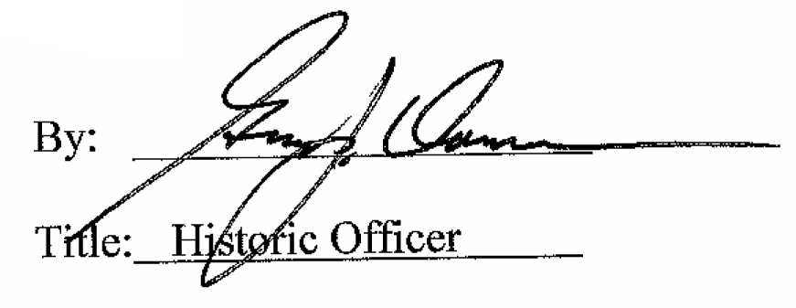

Date of Meeting: Octrober 7, 2015

